Basics to Production Level Topics Understanding
Wait….
What actually we are doing, just writing the code, or really understanding the end to end working of a application , that how it is internally working.
Suppose you are searching an item on a application portal , do you literally know what internally happens ,when you are sending your request…?
- When we say Client → Server → Database flow, in real production systems this is much more complex than a simple request going to a database. Many layers, components, and system design concepts are involved to make the system scalable, secure, reliable, and fast.

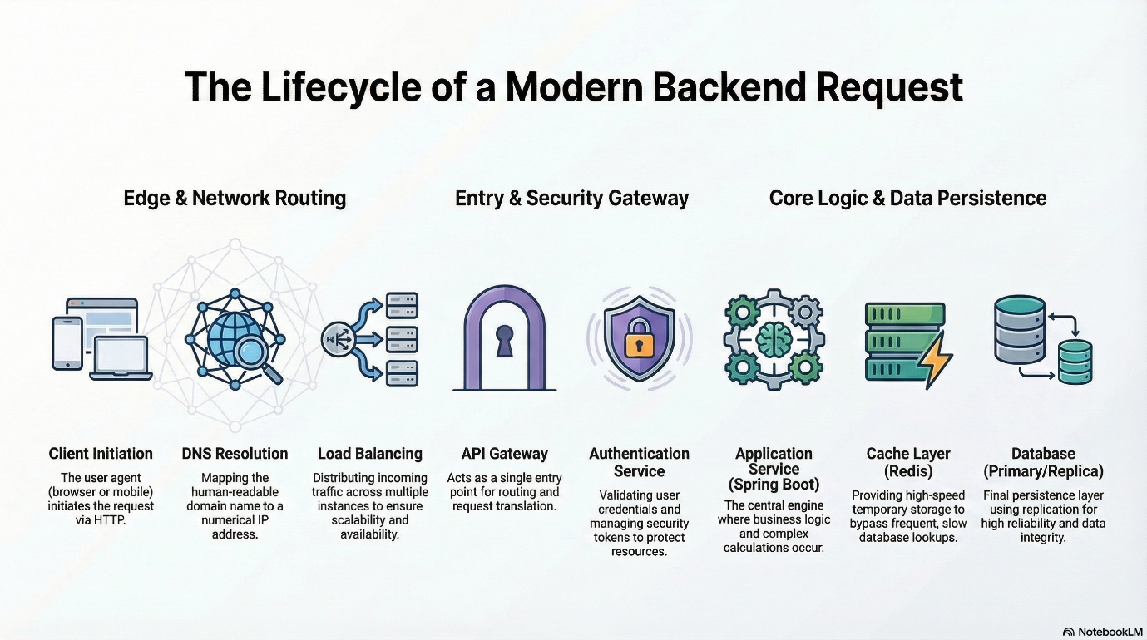

Lets Understand topic by topic:
Browser → Spring Boot API → PostgreSQL.

Step 1: Client Request.
A client can send their request from the respective places like mobile app, web browser or a microservice . ex: GET https://api.company.com/users/10
That particular request contains, headers or a body if json

Step 2: DNS
Then your request comes to DNS/Domain system before reaching the backend server ,the browser resolves the domain name.
Api.companyname.com DNS will convert it into an IP Address
Api.companyname.com 52.18.23.11, this will be often used cloudflare or google cloud DNS.
Step 3: CDN
Suppose our app is containing gif’s , images videos types of data , that data we are putting inside content delivery network.
- If the request is for static content (images, CSS, JS), the CDN serves it.
- CDN improves performance by serving files from nearby servers.
- For APIs, requests go to backend servers.
Reduces Physical Distance (Latency): A CDN solves the problem of slow connections caused by the geographical distance between a user and a primary server. For example, if a database is in Europe and the user is in Asia, a CDN helps by bringing the content physically closer to the user

Step 3: Load Balancer
Load balancer acts as a "traffic cop" that distributes incoming client requests across multiple backend servers. This setup ensures high availability, prevents any single server from becoming overwhelmed, and improves overall application performance.

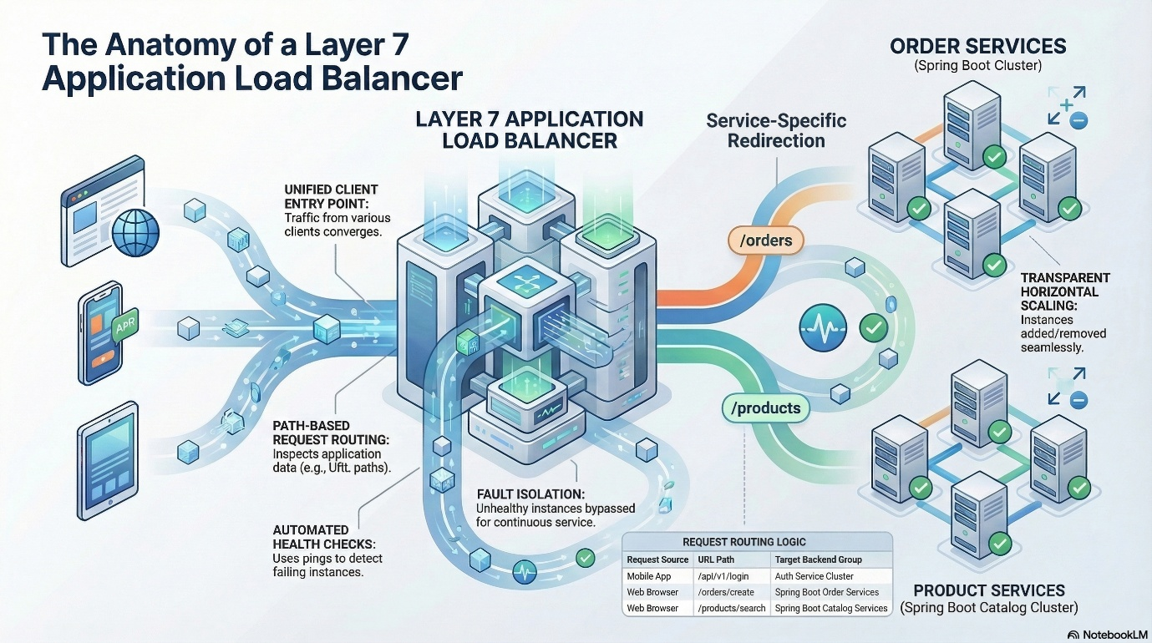

Then what is a difference Between API Gateway and Load Balancer….?

Imagine a shopping Mall
- A load balancer is the security guard at the parking gate
- And an API Gateway is the reception desk inside the mall.
Both help traffic, but they do very important jobs
- Load balancer (Traffic Splitter)
It takes incoming requests
Sends them to one of many servers keeps servers from getting over loaded
Think: which cashier is free? go there
Ex: NGINX, cloud load balancers
It does:
Traffic distribution
Health checks

- API Gateway (Smart Manager)
Sits in front of all API’s
Knows who you are and what you are allowed to do
Adds rules, security and control
Think: “who are you? What do you want? Are you allowed?”
Authentication & Authorization
Rate Limiting
Request/Response transformation
API Versioning
Logging and Monitoring
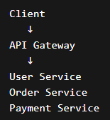

Authentication & Authorization:
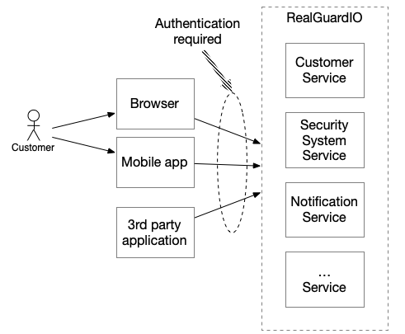
Authentication verifies who a user is (identity), while authorization determines what they can access (permissions). Authentication (e.g., login) happens first, followed by authorization (e.g., role-based access) to secure systems. Common methods include passwords/biometrics for authentication and OAuth 2.0/RBAC for authorization.

Authentication and Authorization are two fundamental security processes that work together to control access to systems and data.
- Authentication: Confirms the user’s identity (proves who the user is).
- Authorization: Controls what the verified user is allowed to do (decides what they can access).
- Order: Authentication always happens first, and authorization follows afterward.

Authentication:
- Authentication means verifying the identity of a user.
- Example: Login with username and password.

- Client Sends user credentials from frontend and sends them to the backend
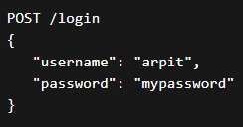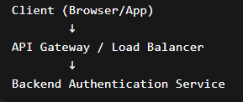
2. Request Reaches Authentication Layer
In frameworks like Spring Security, the request first passes through security filters.
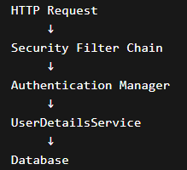
The Filter Chain intercepts requests before they reach the controller.
Then backend tries to details from the db using
SELECT * FROM users WHERE username = 'arpit'
And DB returns
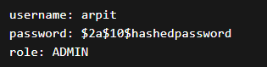
Once this process is done
Authentication Token Generation
Once verified, backend generates a session or token
For that two common methods is there
- Session based authentication
- Token based authentication
- A. Session Based Authentication

- Server creates session
Session ID stored in server memory
Session ID sent to browser cookie

Example:
Set-Cookie: SESSION_ID = AHF8734KJ

Server stores session data:
SESSION_ID → userId + roles

- B. Token Based Authentication

Server generates token:

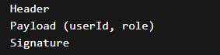

And client stores token in local storage/ cookies


B. Token Based Authentication
Server generates token:
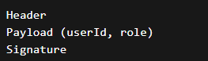
Client Stores Token In Local storage/Cookies, after that Client Sends Token in Future Requests

Request Flow :
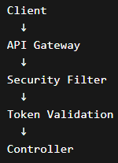
- Authorization:
Authorization means checking what actions the authenticated user can perform.
Admin Create Users
User View Profiles
- Step-by-Step Authorization Flow
- User Sends Request with Token
GET /admin/dashboard
Authorization: Bearer token
- Token Validation
Security Filter Verifies
Token Signature
Token Expiration
Token Integrity
If valid extract user info
- Example Payload:
{
userId: 101
role: ADMIN
}
- Role Extraction:
Backend Extract roles and permission
User → ADMIN
Permissions → READ, WRITE, DELETE
- Access Control Checks :
Authorization Layer Checks
Can ADMIN access /admin/dashboard ?
Implementation methods:
Role Based Access Control (RBAC):
ADMIN → full access
USER → limited access
Example configuration in **Spring Security:
/admin/** → ROLE_ADMIN
/user/** → ROLE_USER

6. Allow or Deny Request
If permission exists:

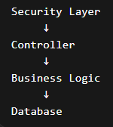
If Not : 403 Forbidden

Production Architecture Example:

